Would you like a change in your life?  Have you lost passion in life? Are you feeling stuck? Do you want joy?  Are you in need of money, financial stability, and/or employment?  Are you confused about life? Are you looking for greater meaning?  Are you physically, emotionally, or spiritually sick and need healing?  Do you wish your relationships can be better?  Are there any struggles that are difficult for you to overcome?  Let us pray for you. Our God is able. Nothing is impossible for Him  http://www.prayertents.com | Would you like a change in your life?  Have you lost passion in life? Are you feeling stuck? Do you want joy?  Are you in need of money, financial stability, and/or employment?  Are you confused about life? Are you looking for greater meaning?  Are you physically, emotionally, or spiritually sick and need healing?  Do you wish your relationships can be better?  Are there any struggles that are difficult for you to overcome?  Let us pray for you. Our God is able. Nothing is impossible for Him  http://www.prayertents.com
Would you like a change in your life?  Have you lost passion in life? Are you feeling stuck? Do you want joy?  Are you in need of money, financial stability, and/or employment?  Are you confused about life? Are you looking for greater meaning?  Are you physically, emotionally, or spiritually sick and need healing?  Do you wish your relationships can be better?  Are there any struggles that are difficult for you to overcome?  Let us pray for you. Our God is able. Nothing is impossible for Him  http://www.prayertents.com | Would you like a change in your life?  Have you lost passion in life? Are you feeling stuck? Do you want joy?  Are you in need of money, financial stability, and/or employment?  Are you confused about life? Are you looking for greater meaning?  Are you physically, emotionally, or spiritually sick and need healing?  Do you wish your relationships can be better?  Are there any struggles that are difficult for you to overcome?  Let us pray for you. Our God is able. Nothing is impossible for Him  http://www.prayertents.com
Prayer Tents, 6pm-9pm, August 17, 2013. Come, it’s for you.  1155 Hendricks Causeway, Ridgefield, NJ 07657  How it works:  1. Come with your prayer requests. Come with expectation that God will answer your requests.  2. We will pray for your specific prayer requests.  3. May the Lord give you guidance and answers to your prayers  4. You are welcome to hang out to ask any questions and/or talk about your circumstances. Pastors will also be available for personal counseling/guidance if desired.  We’ll be cooking burgers and hotdogs. Join us for the feast.  Hang out with us. Get your prayers answered.  And the prayer offered in faith will make the sick person well…  The prayer of a righteous person is powerful and effective. (James 5:15-16)  Healthy people don’t need a doctor—sick people do. I have come to call not those  who think they are righteous, but those who know they are sinners.(Mark 2:17) | 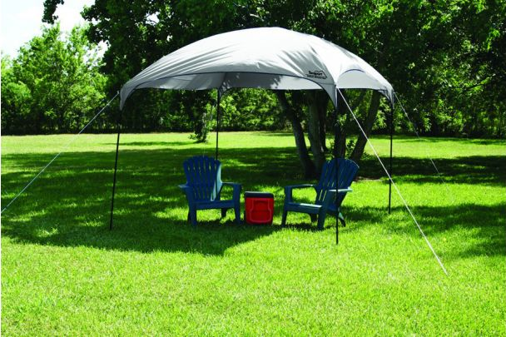  Prayer Tents, 6pm-9pm, August 17, 2013. Come, it’s for you.  1155 Hendricks Causeway, Ridgefield, NJ 07657  How it works:  1. Come with your prayer requests. Come with expectation that God will answer your requests.  2. We will pray for your specific prayer requests.  3. May the Lord give you guidance and answers to your prayers  4. You are welcome to hang out to ask any questions and/or talk about your circumstances. Pastors will also be available for personal counseling/guidance if desired.  We’ll be cooking burgers and hotdogs. Join us for the feast.  Hang out with us. Get your prayers answered.  And the prayer offered in faith will make the sick person well…  The prayer of a righteous person is powerful and effective. (James 5:15-16)  Healthy people don’t need a doctor—sick people do. I have come to call not those  who think they are righteous, but those who know they are sinners.(Mark 2:17)
Prayer Tents, 6pm-9pm, August 17, 2013. Come, it’s for you.  1155 Hendricks Causeway, Ridgefield, NJ 07657  How it works:  1. Come with your prayer requests. Come with expectation that God will answer your requests.  2. We will pray for your specific prayer requests.  3. May the Lord give you guidance and answers to your prayers  4. You are welcome to hang out to ask any questions and/or talk about your circumstances. Pastors will also be available for personal counseling/guidance if desired.  We’ll be cooking burgers and hotdogs. Join us for the feast.  Hang out with us. Get your prayers answered.  And the prayer offered in faith will make the sick person well…  The prayer of a righteous person is powerful and effective. (James 5:15-16)  Healthy people don’t need a doctor—sick people do. I have come to call not those  who think they are righteous, but those who know they are sinners.(Mark 2:17) | Prayer Tents, 6pm-9pm, August 17, 2013. Come, it’s for you.  1155 Hendricks Causeway, Ridgefield, NJ 07657  How it works:  1. Come with your prayer requests. Come with expectation that God will answer your requests.  2. We will pray for your specific prayer requests.  3. May the Lord give you guidance and answers to your prayers  4. You are welcome to hang out to ask any questions and/or talk about your circumstances. Pastors will also be available for personal counseling/guidance if desired.  We’ll be cooking burgers and hotdogs. Join us for the feast.  Hang out with us. Get your prayers answered.  And the prayer offered in faith will make the sick person well…  The prayer of a righteous person is powerful and effective. (James 5:15-16)  Healthy people don’t need a doctor—sick people do. I have come to call not those  who think they are righteous, but those who know they are sinners.(Mark 2:17)

